Tree beating

Tree beating is used to look at invertebrates in trees or large bushes. This survey is often easier to do in pairs.

**For this survey you will need:**

* A beating collection net (an old bed sheet works well. White is a good choice as it’s easier to spot any insects.)
* Large stick
* Small plastic containers for insects
* Magnifying glass
* Pen/pencil

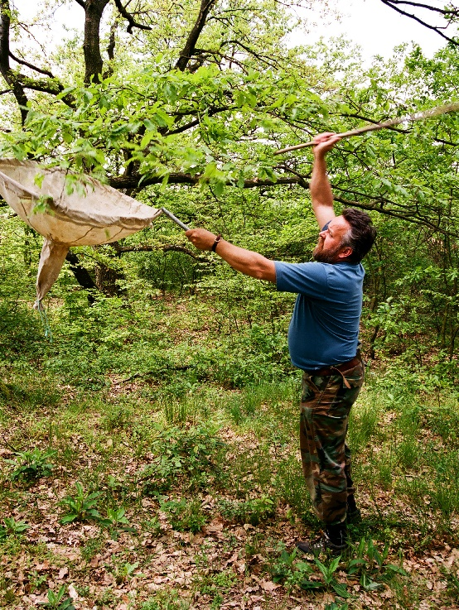

**How to:**

* Place your large catching net or sheet under a tree. If you have a net, you can hold it or you can place the sheet on the ground if the tree or bush is a bit smaller.
* Use a stick to hit the tree so that the branches shake, and insects fall into the net. You can also shake the branches by hand.
* You might want to collect some insects in plastic containers so you can have a better look at them without them flying away.

**Things to be aware of:**

* Remember that some flying insects can escape easily. It’s also important to be careful if you catch and butterflies or day-flying moths as their wings are quite delicate. Also take care removing insects like bees as they can sting.
* Use the same number of hits or shakes per tree. It’s a good idea to record this information so you know in case you want to carry out more tree beating in future.
* Try to hit or shake at a similar height on each tree.