Sweep netting

Sweep netting is used to survey at invertebrates in long grass. It useful for finding both mobile and stationary invertebrate.

**For this survey you will need:**

* Sweep net.
* Small plastic containers or bug pots to collect insects.
* Magnifying glass.
* Pen or pencil.

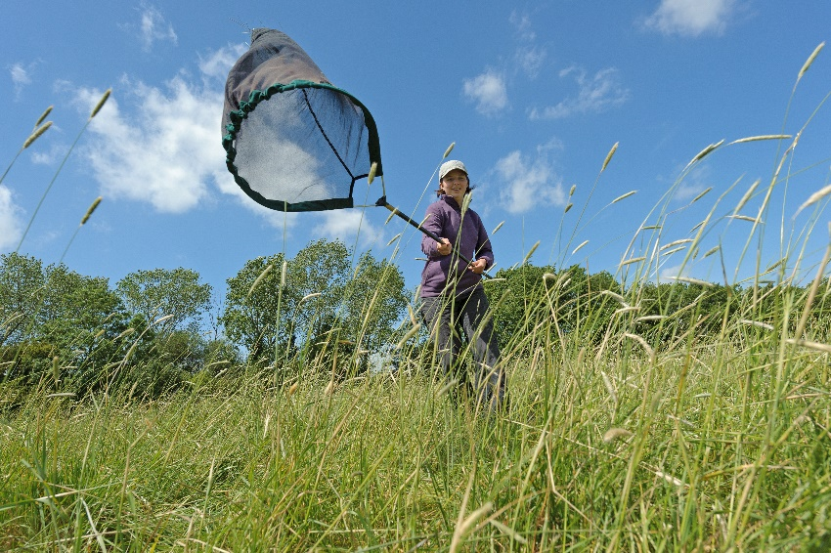

Chris Gomersall 2020VISION

**How to:**

* Before you start, decide how many sweeps you are going to do each time.
* Move your net in sweeping motions through long grass.
* After your set number of sweeps, close the top of your net to stop anything escaping or flying away.
* Carefully open the net and have a look at what insects you have caught before shaking them all out. You might want to collect some of the insects in plastic containers so you can have a better look at them without them flying away.

**Things to be aware of:**

* Use same number of sweeps for every sample/site that you survey. It’s a good idea to record this information so you know in case you want to carry out more sweep netting in future.
* Try sweep at the same height in the grass at every sample/site.
* Remember that some flying insects can escape easily. It’s also important to be careful if you catch and butterflies or day-flying moths as their wings are quite delicate. Also take care removing insects like bees as they can sting.

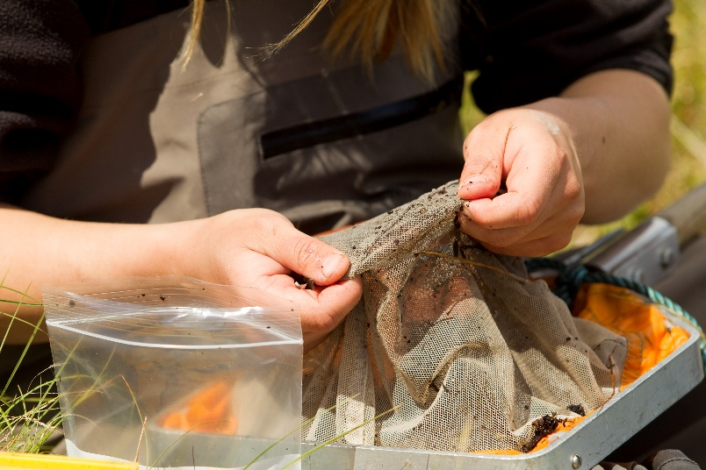

Mark Hamblin 2020VISION