Pond dipping

Pond dipping is one of the most well-known survey methods for freshwater. It’s commonly used with children but is a great way of seeing what wildlife is about. Despite its name, pond dipping is used to survey invertebrates in ponds, lochs and other small water bodies.

**For this survey you will need:**

* Tray (ideally it should be deep enough to hold some water)
* Sieve or a net
* Magnifying glass

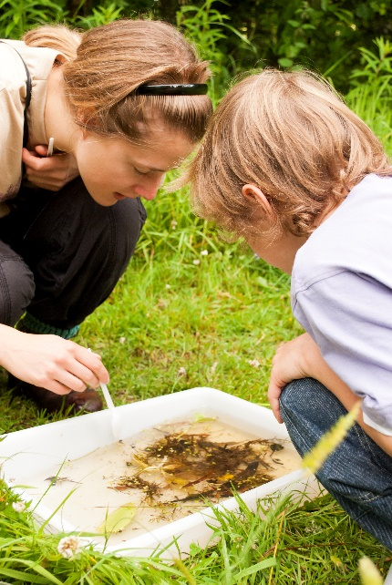

Credit: Katrina Martin

**How to:**

* Scoop some pond water into your tray. This is to put anything you catch in so don’t worry about getting lots of wildlife at this stage.
* Next, gently sweep your net under the water, trying not to disturb the mud at the bottom. A figure of 8 shape works well.
* Lift your net out the water and turn it inside out so anything you’ve caught drops into your tray.
* After you’ve had a look and identified your catch, carefully tip the water back into the pond. Hold the tray closer to the water so that your wildlife doesn’t fall from too high up.

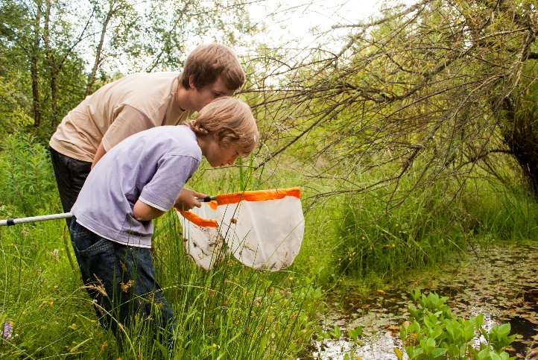

Credit: Katrina Martin

**Things to be aware of:**

* Be careful of deeper water when pond dipping with children. Some ponds have pond dipping platforms which can help.
* Invertebrates that live in the sediment and mud at the bottom of water are less likely to be surveyed. Avoid dragging your net through the mud and sediment at the bottom of the water as you are unlikely to catch anything. It can disturb the wildlife hiding there and just means you have to clean your net!