Pitfall traps

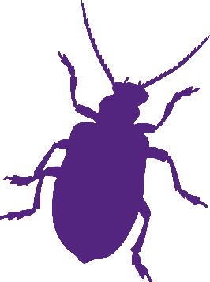Pitfall traps are used to look at ground dwelling invertebrate species. This survey technique is ideal for surveying insects that live underneath bushes and low undergrowth.

**For this survey you will need:**

* Plastic cup
* Trowel
* Pen and pencil
* Magnifying glass

**

**How to:**

* Dig a small hole in the ground and place the plastic cup inside. The cup must be below ground level to allow insects fall in.
* Leave the cup overnight and any insects crawling past will be trapped as they fall in.
* If the weather forecast is rain, place a small canopy shelter over the cup to stop it filling with water. You can balance a piece of wood over the top but make sures there’s room for the insects to crawl in.

**Things to be aware of:**

* The cup rim must not be higher than ground level as if there is a lip, insects won’t fall in.
* If it is forecast to rain, put a small cover over the top of the cup to stop the cup filling with water. This helps keep the trapped insects safe from drowning!
* Flying insects, like beetles, might escape easily.
* Some insects can crawl out.
* Only a small habitat area is surveyed.