Moth trapping

Moth trapping might sound a bit cruel but it’s actually a very simple survey technique. Moth trapping uses a light or food source to attract moths. You can buy moth traps online, but you can also make one at home.

**For this survey you will need:**

* White sheet
* Washing line (if you are surveying out on a site, a bit of string works too.)
* Pegs
* Bright lamp or torch

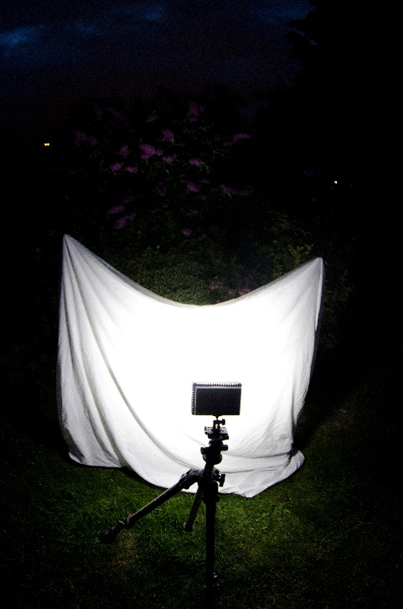

Credit: Jack Perks

**How to:**

* Use your pegs to hang your sheet at one end with the other hanging down to the ground. It doesn’t matter if it reaches the ground; a small gap or bit of sheet on the ground is fine.
* Turn off any other lights and then shine your bright light at the sheet. The light will attract lots of moths which you can then identify.
* If you need to, you can use bug pots to catch some moths to help identify them.

Credit: Ross Hoddinott

**Things to be aware of:**

* Avoid touching moths’ wings as they are easily damaged.
* Choose a warm night with little wind as this is when more moths will be active.
* The brighter the light the more moths it will attract. Remember that if you are in a built-up area, you might need to warn the neighbours that you will be shining a light at night!