Kick sampling

Kick sampling is a useful method for surveying invertebrates in shallow, flowing water. It can be used to find insects both in the water and hiding amongst any rocks or other shelter. It’s best used in streams or small rivers with flowing water.

**For this survey you will need:**

* Tray (ideally it should be deep enough to hold some water)
* A net
* Magnifying glass
* Wellies or waders

**How to:**

* Scoop some water into your tray.
* Place the net in water downstream for where you are standing.
* Using your boot, gently kick the sediment and rocks in the direction of the net. Normally 4-5 kicks will do.
* Next, empty the contents of your net into a tray where you can identify the invertebrates.

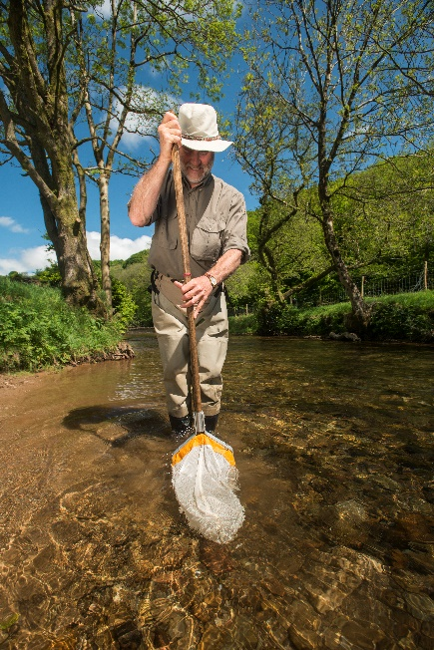

Credit: Ross Hoddinott

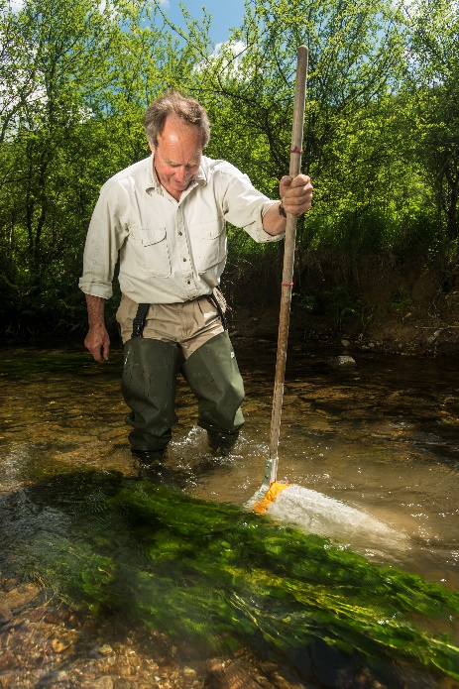

Credit: Ross Hoddinott

**Things to be aware of:**

* Be careful of deeper water and fast flowing streams or rivers.
* Be gentle when kicking the rocks and debris so you don’t hurt any of the wildlife.
* Make sure you keep your net close to where you are kicking from so you catch the invertebrate that are flushed up.